Ali Shiri is a Professor at the School of Library and Information Studies in the University of Alberta, teaching courses in the areas of digital libraries and information organization and retrieval. His research areas centre on digital libraries, search user interfaces, user interaction with digital information and learning and data analytics.

Pronoun: he/him

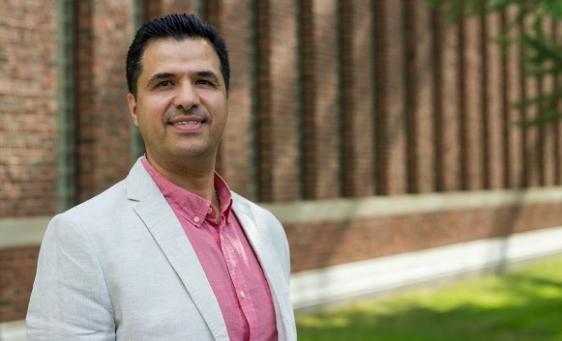

Emily Villanueva is a graduate student pursuing her MA/MLIS degrees at the University of Alberta’s School of Library and Information Studies and Media and Technology Studies unit. Her interests reside at the intersection of LIS and the social sciences, with a focus on information behaviours and identities in digital spaces.

Pronouns: She/her

